## Chapter 1 Introduction

### 1.1 Chapter Overview

The introduction is going to describe the overall criteria of this project, that is a recommendation application for apartments. This chapter clearly describes the research on this project’s background, proposed solution, features of the prototype that’s been made as well as how this project was broke down into series of tasks to achieve the goal and has been projected with project deliverables and Gantt chart. This also includes the aims and objectives of this project and how it will affect the brokering of houses in a positive way.

### 1.2 Project Background

When it comes to choosing a new apartment to live in, we come across many of them with different features, and people find it on their own or either got through real estate agents or business brokers to achieve their ideal home. Centrality and neighborhood are key aspects that decide a value of an apartment. When people tend to choose the apartments they often look within the internal factors of the apartment that makes them more suitable for living such as house décor, floor, facilities and price, yet they tend to overlook external factors that may affect their way of life such as public spots, places of interests, distances to places of interests(work, school), traffic time alone their ideal day to day pathways and such which results in regret of making such life changing one time only decision for some people. Hence through this project we tend to eliminate that problem.

Following are the prerequisites for the project,

* Data regarding available apartments.
* Google Maps API.
* Google Cloud hosted TensorFlow application.

Accurate data on relevant areas regarding crime, financial status, society status. When a user wants to find an apartment to live in, he simply gives the system of basic information such as place, price, location of places of interests and facilities that he/she looks for. System then takes this information and finds apartments that would satisfy the needs of the user then correlates with other data such as crime rate, financial status and such and recommends a viable and proper apartment amidst a good neighborhood. The output of the process will display the information regarding the apartment with other data such as travelling time needed between his places on interest, crime rate and such in simple UI format that anyone could be able to understand.

### 1.3 Problem Definition

The problem defined is as follows; One of the most common problem that we found was that most of the people buy/rent an apartment with minimal background knowledge and sometimes we invest a large amount of money for an apartment that might not have good external nor internal factors but it’s the first apartment we found when we searched. When it comes to advertising apartments for the people to buy/rent the sources people use to choose from are mostly newspaper ads and websites. When it comes to these advertisements, they are basically providing one dimensional information. Most of us desire for a good investment and sometimes we succeed in good investing and most of the times we fail.

**1.5 Research Question**

How to find apartments that will fulfill our preferences that will satisfy our external and internal needs?

### 1.6 Project aim

*The aim of the project is to provide the users with an ability to buy/rent their desired apartment which meets all their requirements using a hybrid application.*

This will enable the users to analyze the factors affecting the internal environment of the apartment as well as the external factors and these data gathered are corresponded with places surrounding the area, financial value of the area and crime rate of the area given and then the recommendation engine would suggest a very improved and better recommendation.

**``1.7 Project objectives**

The following are the project objectives and academic objectives identified in this project.

**Project Objectives**

|  |  |  |
| --- | --- | --- |
| No | Project Objectives | Description |
|  | Prepare the proposal to validate the idea. | Identify the aim and the objectives of the system.  Recognize the features of the system.  Identify project deliverables. |
|  | Performing a Literature Review | To clarify the problem domain and the research context.   * The current problem * Defining the methods of approaching and solving the defined problem with justifications * Analysing the technologies and identifying the appropriate technologies needed by our system. * Compare and contrast previous methods and techniques used by researchers * Comparing and learning from previous work |
|  | Define project planning and software development methodologies | Compare and contrast the methodologies and finding the most suitable approach for the project. |
|  | Gathering requirements through Requirement Engineering. | By doing a proper requirement gathering and analysis to identify the functional and non-functional requirements and to find proper tools and technologies that can be used. |
|  | Creating the requirement specification Document. | Preparing the document based on the finding of the requirement engineering which includes the functional and non-functional requirements of the system |
|  | Preparing the design document | This will show the design of the system before starting the development of prototype.   * Recognizing suitable design approaches to be used. * Design the system * Documenting the design of the system. |
|  | Developing prototype of the system | Implementing the system using the most suitable resources with the core functionality.  Creating a prototype report. |
|  | Testing | Writing test cases and using test methods and running test of the protype and analyzing the results obtained from various tests.. |
|  | Evaluating the prototype | Carrying out reviews with domain experts and further improve the prototype.  Proper requirement validation against the requirements specified. |
|  | Conclusion of the project and Complete Documentation |  |
|  | Table 1: Operational and Academic Objectives of this project (Chapter 1.5)  **Academic Objectives** | |

|  |  |
| --- | --- |
| No | Academic Objective |
|  | Working as a team and developing team coordination. |
|  | Working as a team and developing team coordination. |
|  | Learning android development to build our prototype. |
|  | Learning machine learning to build our prototype. |
|  | Understanding the design patterns of the software development. |

**1.8 Project Scope**

1.8.1 In-Scope

1. System will successfully work with the Language English
2. System targets context of Srilanka
3. Finds appartments based on users preference
4. Buyers can search for any apartment feature they want.
5. The system will show the recommended location on map with your work place and all the places that are close by which will make it a better place.

1.8.2 Out-Scope

1. Reviews of surrounding places wont affect the model.
2. Not out of western province.
3. No translation other than English Language
4. Generalized preference only, we will not recommend for a user’

### 1.9 Features of Prototype

1. User will be able to register themselves as customers of the service.
2. User will be able to login themselves.
3. User will be able to set up his preferences or change it as he wishes.
4. Application will record user’s interaction as the application runs.
5. Application will get details regarding the surrounding are through the google maps API.
6. Application will have a wishlist which will have all your recommended properties with different properties for comparison
7. Application will be able to recommend an apartment based on the details of user and area and apartments.
8. The recommended apartment can be seen using map view to see where it is located geographically and it will show all the pinned preferable locations nearby.

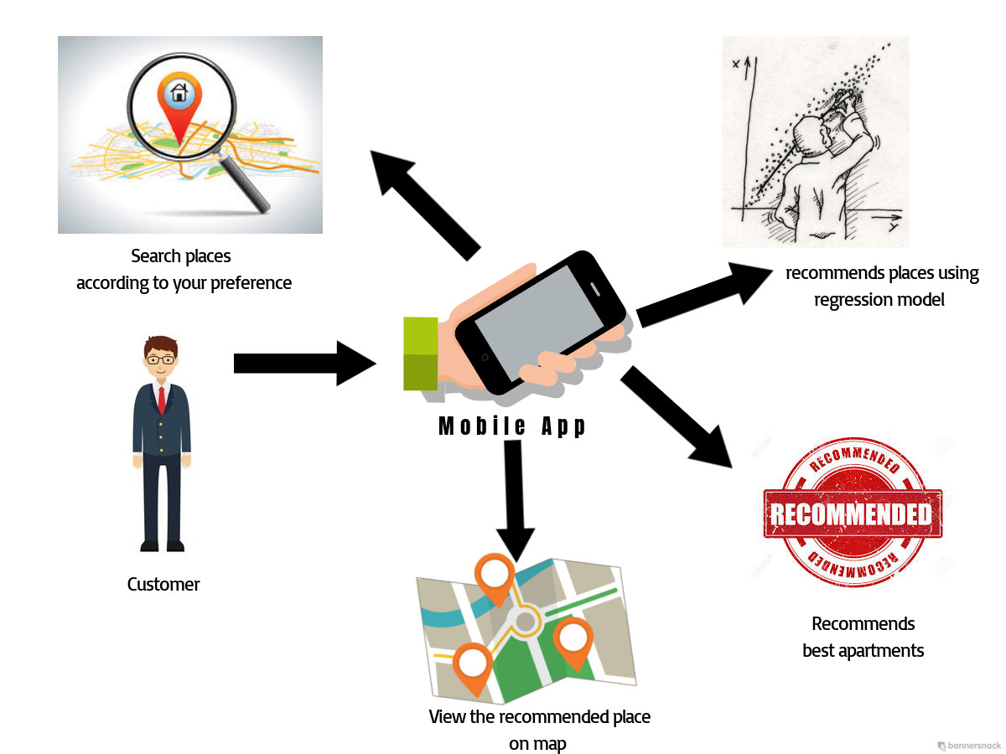

#### 1.10 Deliverables

#### Project Deliverables

The following are the project deliverables identified in this project:

1. Terms of Reference
2. Literature Review
3. Design Specification
4. Project software requirement specification
5. Interim Report
6. Proof Of concept of product or prototype-This will be created with limited functionality in the scope of recommendation of apartments.
7. Testing Report
8. Final product-This will be the final product of our project including all functionality.
9. Final Report

### Product Deliverables

1. Success rate of the demand of apartment in certain location
2. Report on different factors governing the apartment purchase success rate and failure.
3. Feasibility report for the construction companies.

**1.11 Resource Requirements**

Following are the minimum resource requirements identifies to develop the system.

|  |  |
| --- | --- |
| Software Requirement | **Justification** |
| Android SDK | to develop the android application |
| Android OS | to run the APK file. |
| Python |  |
| PyCharm |  |
| Google cloud |  |
| Google Map API | To pinpoint the location and provide a recommended apartment using it |

|  |  |
| --- | --- |
| Hardware Requirement | Justification |
| Core i5 or above processor | To process the data and analysis within a short time period |
| PC windows with 8GB RAM | Since most of the processes need a high speed access memory RAM needs to be at higher capacity |
| Android running smartphone | To support our system and display the application. |

**1.12** **Planning and Management**

#### 1.12.2 Gantt Chart

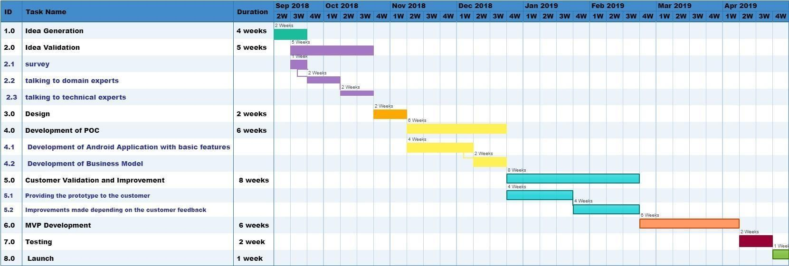Figure 1.1: Gantt Chart of Apartment Recommendation Project

#### 1.12.3 Work breakdown

|  |  |
| --- | --- |
| **Timeline** | **Task** |
| Week 1 to Week 8  (3 months) | 1st to 4th Week: Generation of an idea to develop a startup.  5th to 8th Week: Validation of the idea by sending survey and doing a preliminary study and talking to domain experts, technical experts and people who are related to the field to solidify the problem. |
| Week 8 to Week 16 | 8th to 10th Week: Development of POC and Business Model Generation.  10th to 16th Week: Developing an android application which will have certain basic features which will be our proof of concept. |
| Week 16 to Week 24 | 16th to 20th Week: Providing our prototype which will be the application to the customer and analyze the requirements that have been met as agreed and getting feedback from the customer of the additional requirements.  20th to 24th Week: Making improvements on our prototype and adding additional functionality. |
| Week 24 to Week 32 | 24th to 28th Week: Development of a minimum viable product with enough features and functionality to satisfy early customers and to provide feedback for future product development.  28th to 32th Week: Launching the product with subscription for first 6 months to be free. |
| Table 1,1: work breakdown of group work | |

In future development we are planning to diverse the area focused to all the business types and giving the user a feasibility study of a location and suggest the business type they could start.

## 1.13 Document Structure

The chapters included in the report is as follows:

**Chapter 1: Introduction**

This chapter is going to describe the research on this project’s background, proposed solution, features of the prototype that’s been made as well as how this project was broke down into series of tasks to achieve the goal and has been projected with project deliverables. This chapter also includes the aims and objectives of this project .

**Chapter 2:Literature Review**

This chapter will evaluate the existing solutions in order to know the strengths and weakness.

This chapter has in depth analysis of the previous works carried out by other researches.

After conducting a literature review we can identify the limitations and identify issues and the steps that can be taken to overcome some of them.

**Chapter 3: Requirement Specification**

This chapter It describes specifically about the methods and techniques to elicitate, analyses the requirements of the Recommendation system.It will also contain Thematic analysis of Expert surveys, Public surveys, Interviews .It will also include about the models, and the restructured scope of our project after analysing the requirements gathered.The most suitable research methodology and development methodology for the project will also be discussed.

**Chapter 4 : System Architecture and Design**

This chapter discusses the High-level system architecture, which was modelled and discussed in terms of modules. This chapter also discusses the design of the system which is based on the approach for the proposed hybrid recommender engine.It also consist the low-level design diagrams such as domain model, sequence diagrams are discussed followed with an explanation of the design and architectural patterns that were adopted and the design goals of the system.

**1.14 Chapter Summary**

This chapter started off with the discussion of the problem and gives the research made for this project’s background, next moved on to the proposed solution, aim of the project, objectives and features of the prototype and then lastly the chapter focuses on the project management to achieve the goal and has been projected with project deliverables and Gantt chart.